# IT Work

In order to provide the required information on IT work, we elected to interview an IT Professional in order to understand more about the IT industry.

The IT Professional we interviewed was Scott McCormack from Chironix in Perth.

Web: [www.chironix.com](http://www.chironix.com)

LinkedIn: <https://www.linkedin.com/in/scott-mccormack>

GitHub: <https://github.com/ScottMcCormack>

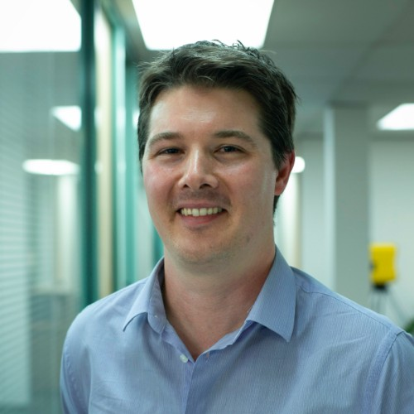

Scott McCormack

Chironix is a software development company focused on robotic autonomy and artificial intelligence. Chironix work in specialist areas and as such their expertise is in demand globally. Their wearables division covers wearable and IoT devices for mobile personnel, such as first responders, maintenance technicians and defence. The applied robotics team work on autonomous robotic solutions, specialising in harsh environments, such as the mining industry. The Machine Learning and Cloud Computing teams use a range of solutions to solve client’s problems.

In Scott’s role as the Lead Cloud Architect, he leads a team of software developers creating novel applications that interact with and leverage cloud services. The role also involves providing cloud consulting to clients looking to move to the cloud. This may in the form of advisory consulting, where they require assistance with planning, or this may be managing professional services where the client may be executing their migrations. As a Data and Analytics specialist, a lot of the newer work with clients is on the advisory side, looking at how they can gain more value from their existing data and begin to make use of machine learning and artificial intelligence. Scott estimates that approximately 50%-60% of his time is client facing, either in a presales or consultative capacity. The majority of his remaining time is spent producing reports on the client interactions or managing his team.

There is a wide range of technologies that Scott uses within his day to day business, such as software to manage client interactions and projects, such as Jira. There are also a number of collaboration tools, including G Suite, that Scott uses to maintain effective communications through video conferencing, text-based chat and emails.

Scott works with numerous stakeholders in his work locally, nationally and internationally with a wide range of interests and personalities. As a solutions partner, Chironix focus a lot of their time with clients. With these clients, this may be technical stakeholders as well as business and operations staff to gain an understanding of their problems. In Scott’s words “What’s the point of spending time in a business to try and help them if you don’t know what’s broken”. Scott works with a lot of different industries, however as a WA headquarted organisation that specialises in robotics, there is a resources heavy focus to the industries. Many of the companies are either resources/industrial or support the resources industry.

There are also internal stakeholders that Scott deals with, managing the team of software developers of varying skillsets and experience, along with sales and marketing professionals to assist with driving new business.

Reading and tailoring the approach to each type of person and meeting Scott has found essential to being able to communicate, maintain positive working relationships and produce good outcomes.

Scott illustrated his work life with a typical example of a client he recently worked with to deliver a Data Analytics platform for in Perth.

Initially Google had engaged with the customer to discuss how they could improve their platform. As Chironix are a Google partner, Scott and his managing director were engaged by Google to work with them and the client. As part of the initial phase, this involved gaining an understanding from Google what had been discussed with the client and working with his managing director and the client to sell the value of partnering with both Google and Chironix to the client. After this initial phase, this involved engaging the clients existing data team to understand what they had and some of the technical challenges in addition to their operations manager, delivery manager and marketing team to understand and gather their requirements. Following this Scott engaged with Google’s technical team and Chironix’s software development team to create and validate a solution that would meet all the requirements that they had gathered. This is the part that Scott really enjoys, working to develop an innovative solution that works and can’t simply be bought off the shelf. Scott then managed and oversaw the delivery of the proof of concept with the client to ensure that expectations where met on all sides. Keeping both the client and the vendor informed and happy is a tough challenge in these interactions as often priorities can conflict.

From this example it’s clear that there is a wide range of complex people that Scott deals with, both technical and non-technical and requires strong communication skills to manage these relationships.

Scott finds the people side the most challenging part of working in IT. Technologies change and that is a challenge to keep up with, but technology changes linearly. You expect new technologies and disruptions to happen in IT. The primary resource required to stay on top in technology is time, which is a scarce commodity, but can be managed. However, people vary a lot more than technology in Scott’s opinion. Dealing with people is a skill that takes time to master and requires constant dedication to maintain good relationships.

As someone who manages a developer team with a number of recent graduates, we asked Scott what advice he would give to someone beginning their career in IT. Scott would advise anyone who is starting their career in IT to be measured in their opinions and to be mindful of the approaches they take when starting their work. He has seen often with new graduates they move straight into “solutioning mode” without always considering all the challenges that may lay before them.